#CFS-01 Call For Sevice

Technical Design Document

Author: Tuan Nguyen

Email: nguyenanhzin@gmail.com

# Document Revision History

|  |  |  |  |
| --- | --- | --- | --- |
| **Date** | **Version** | **Editor** | **Notes** |
| 05 Mar 2021 | 0.1 | Tuan Nguyen |  |
|  |  |  |  |
|  |  |  |  |
|  |  |  |  |
|  |  |  |  |
|  |  |  |  |

# Business Overview

The CFS should be developed with the following modules:

1. **CFS - Creating**:

* User should be able to create a CFS with the following information: event number, event  
  type (with type code), event time, dispatch time, responder

1. **CFS- Searching**:

* User should be able to search for CFS within a time range with paging and sorting order.
* User should be able to search for CFS that assigned to a responder.

# List of Features/Tickets

|  |  |  |  |  |
| --- | --- | --- | --- | --- |
| # | Feature/Ticket Title | Feature/Ticket Description | Workload  (hrs) | Mockup |
| 1.1 | #CFS-01-01 As a user, I can create a CFS | Access to CFS menu |  | NO |
| 1.2 | #CFS-02-01 As a user, I can search for CFS within a time range with paging and sorting order | Access to CFS menu |  | NO |
| 1.2 | #CFS-02-02 As a user, I can search for CFS that assigned to a responder | Access to CFS menu |  | NO |

# Roles/Permissions and Screen affected

|  |  |  |
| --- | --- | --- |
| **Role** | **Permissions** | **Screen** |
| Normal User | see all CFS belong to their Agency | CFS |

# Technical specifications

## # CFS-01-01 As a user, I can create a CFS

*Description:*

Adding new CFS, includes:

* Event number: string
* Event type (with type code)
* Event time
* Dispatch time
* Responder
* Agency_id

*Acceptance Criteria:*

1. User can create a CFS belong their agency
2. Event number should not be null or empty
3. Event type should belong Type code
4. Event Time should not be null or empty. The time should right with format "yyyy-mm-dd hh:mm:ss.fff"
5. Dispatch Time should not be null or empty. The time should right with format "yyyy-mm-dd hh:mm:ss.fff". The Dispatch Time should larger then Event time
6. Responder should belong same Agency with current user

## # CFS-02-01 As a user, I can search for CFS within a time range with paging and sorting order

*Description:*

As a user, I can search for CFS within a time range with paging and sorting order:

* Time Range
  + Start time
  + End time
* Paging size:
  + 10
  + 20
  + 50
  + 100
* Sorting order by Event Number:
  + Descending
  + Ascending

*Acceptance Criteria:*

1. User should see all CFS belong to their Agency
2. The results should belong between Event time and Dispatch time with time range
3. The results should order by sorting
4. The results should not belong other agency

## # CFS-02-02 As a user, I can search for CFS that assigned to a responder

*Description:*

As a user, I can search for CFS that assigned to a responder:

* ResponderId

*Acceptance Criteria:*

1. User should see all CFS that assigned to a responder
2. The results should not belong other agency
3. **System Analyze**

**6.1 User Case diagram for normal user**

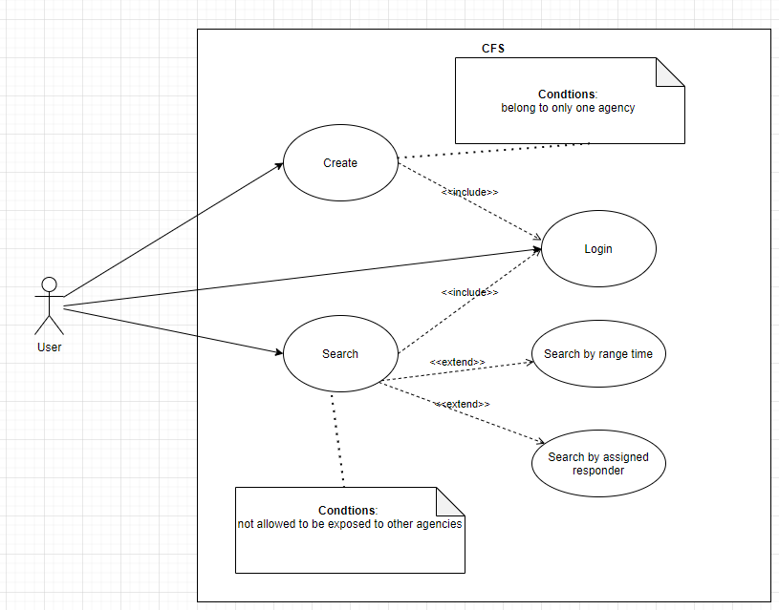

* 1. **Data Model**

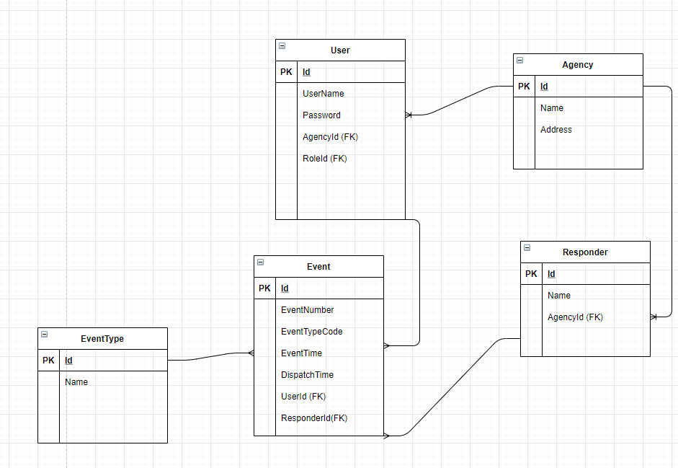

* 1. Database Design

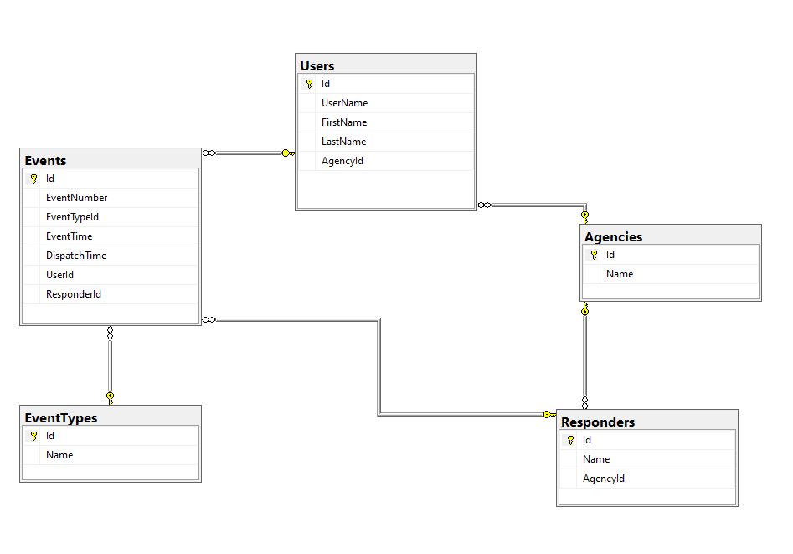

* 1. **Api Contract**

**6.5.1 CFS-01-01 As a user, I can create a CFS**

## ****POST /events****

Creates a new Event and returns the new object.

* **URL Params**  
  None
* **Headers**  
  Content-Type: application/json
* **Data Params**

{

"agency_id": "4f9b99eb-490a-484e-bade-15e3841dfda9",  
"event_id": "562c89de-f140-4482-8ef5-5f1703b286b6",  
"event_number": "3234019",  
"event_type_code": "SMO",  
"event_time": "2020-11-25 07:36:04.193",  
"dispatch_time": "2020-11-26 13:55:46.466",  
"responder": "OFFICER_001"

}

* **Success Response:**
* **Code:** 200  
  **Content:** { <event_object> }

**Error Response:**

* **Code:** 400  
  **Content:** { messages : [

“Cannot find user”,

“Responder should not be null or empty”,

“Responder is not exist”,

“Event number should not be null or empty”,

“Event type should belong Type code”,

“Event Time should not be null or empty”,

“The event time should right with format ‘yyyy-mm-dd hh:mm:ss.fff’”,

“Dispatch Time should not be null or empty”,

“The dispatch time should right with format "yyyy-mm-dd hh:mm:ss.fff"”,

“The Dispatch Time should larger then Event time”,

“Agency is not the same”,

]

}

**6.5.2 #CFS-02-01 As a user, I can search for CFS within a time range with paging and sorting order**

## ****GET /search****

Search event with time and paging and returns the new object.

* **URL Params**  
  None
* **Headers**  
  Content-Type: application/json
* **Data Params**

{

"responder_id": "",  
"event_time": "2020-11-25 07:36:04.193",  
"dispatch_time": "2020-11-26 13:55:46.466",  
"page_size": "1",

"page_limit": "50",

}

* **Success Response:**

**Code:** 200  
**Content:** { <event_object> }

**Error Response:**

**Code:** 400  
**Content:** { errors : [

“The Dispatch Time should larger then Event time”

]

}

**6.5.3 #CFS-02-02 As a user, I can search for CFS that assigned to a responder**

## ****GET /search****

Search event with **responder** and returns the new object.

* **URL Params**  
  None
* **Headers**  
  Content-Type: application/json

Authorization: Bearer <OAuth Token>

* **Data Params**

{

"responder": "OFFICER_001",

"page_size": "1",

"page_limit": "50",

}

* **Success Response:**

**Code:** 200  
**Content:** { <event_object> }

**Error Response:**

**Code:** 400  
**Content:** { messages: [

“Cannot find event with responder: {responder}”,

]

}